# SIYANDA MASEKO WEB DEV PROP. 2

# CRAFTNET SOLUTIONS



## Organisation Overview

Craftnet Solutions is an IT services company that specialises in providing digital solutions to help small businesses grow. The organisation’s current network infrastructure is outdated, which slows down data transfers and increases the risk of cyber threats. To remain competitive in the digital space and to meet the needs of its clients, Craftnet requires a professional and functional website that will showcase its services, improve its online presence, and support business growth.

## Website Goals and Objectives

The primary goal of the new website is to create a platform that reflects Craftnet’s brand identity while serving as a hub for clients and potential customers. The website will aim to enhance visibility, attract and engage small businesses in need of IT solutions, and provide information about services offered by the organisation. It will also support lead generation by offering clear pathways for client inquiries, improve trust by displaying the company’s expertise, and ensure that the site is scalable to accommodate future business expansion.

## Current Website Analysis

Currently, Craftnet does not have a professional, fully functional website. This has limited the company’s ability to market its services effectively, communicate with potential clients, and establish credibility in the IT sector. The absence of a modern website results in a lack of visibility and accessibility. The new website will address these challenges by presenting Craftnet as a professional and reliable IT partner while making it easier for customers to access services and information.

## Proposed Website Features and Functionality

The new website for Craftnet Solutions will include key sections that highlight the company’s strengths and services. The homepage will provide an overview of the organisation and its latest updates. An “About Us” page will outline the company’s background, mission, and vision, while a dedicated “Services” page will detail the IT solutions offered, such as network upgrades, security enhancements, and employee training. A “Contact” page will provide direct communication channels through inquiry forms, contact details, and location maps. In addition, a client support page will be created to host frequently asked questions and resources for small businesses.

2

## Design and User Experience

The website design will use a professional colour palette of blue, grey, and white to convey trust, technology, and reliability. Clear sans-serif typography will be used to ensure readability, with visual hierarchy to guide users through content. The layout will be clean, modern, and responsive, ensuring that the site is accessible across both desktop and mobile devices. User experience will be prioritised through easy navigation, secure communication forms, and clear calls to action. Wireframes and prototypes will be developed to test and refine the user journey before the final build.

**SITEMAP AND WIREFRAME**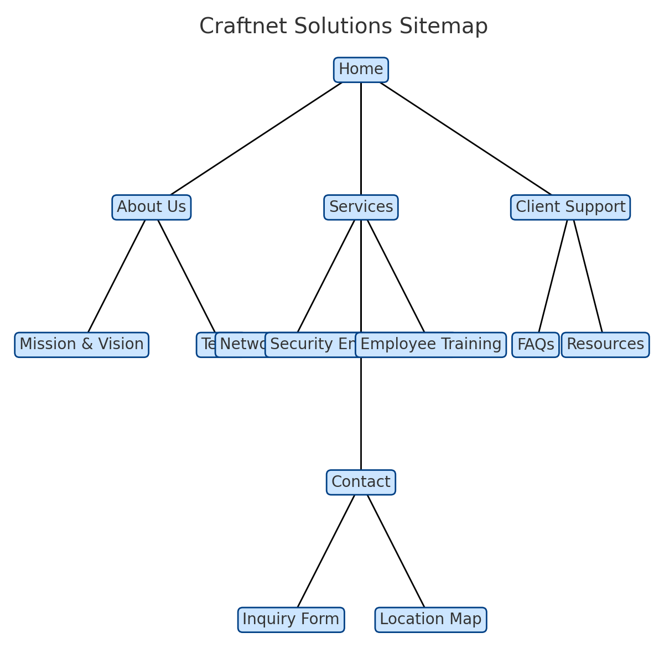

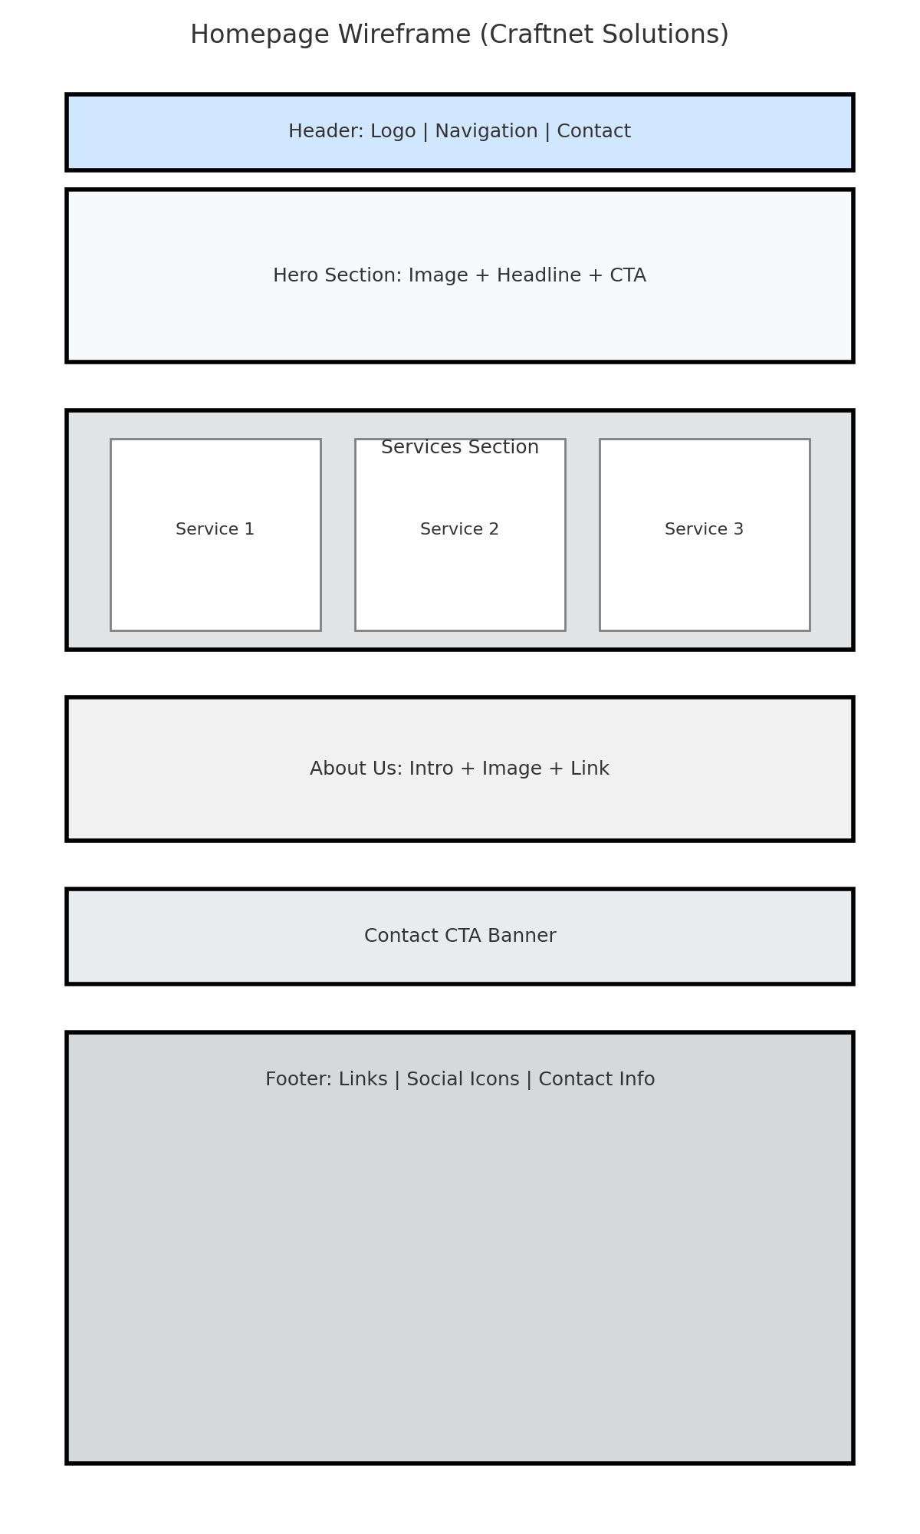

## Technical Requirements

The technical requirements for the project include hosting and domain registration, as well as the development of the website using standard web technologies such as HTML, CSS, and JavaScript. A content management system such as WordPress may be integrated to allow for scalability and easier updates. Security measures such as SSL certificates, firewalls, and regular updates will be implemented to ensure safe browsing for users and protect the company’s data.

## Timeline and Milestones

The website project will follow a clear timeline with defined milestones. The proposal submission will take place on 22 July 2025, with the evaluation and contract award scheduled for 29 July 2025. The project will officially begin on 5 August 2025, and the website is expected to be completed and fully operational by 30 September 2025.

## Budget

The estimated budget for the project is between R250,000 and R300,000. This amount covers all aspects of website development, including design, hosting, domain registration, and security measures. It also includes the training of employees who will be responsible for maintaining and updating the website once it has been launched.

## References

This proposal is based on internal project research into Craftnet Solutions and its infrastructure, as well as general academic references and guidelines from Integrated learning. Garrett, J.J., 2011. The Elements of User Experience: User-Cantered Design for the Web and Beyond. 2nd ed. Berkeley: New Riders.

Nielsen Norman Group, 2020. 10 Usability Heuristics for User Interface Design. [online] Available at: <https://www.nngroup.com/articles/ten-usability-heuristics/>

[Accessed 27 August 2025].

W3C, 2023. Web Design and Applications. [online] Available at: <https://www.w3.org/standards/webdesign/>

[Accessed 27 August 2025].